NUCL 402 HMWK 4

1. Xe Reactivity

$$ρ\left(t\right)=-\frac{1}{vpϵ}\left[\frac{\left(γ_{I}+γ_{X}\right)ϕ}{ϕ_{X}+ϕ}e^{-λ_{X}t}+\frac{γ_{I}ϕ}{ϕ_{I}-ϕ_{X}}\left(e^{-λ_{X}t}-e^{-λ_{I}t}\right)\right]$$

$$ϕ_{I}=-\frac{λ_{I}}{σ_{aX}}=1.055*{10}^{3}\frac{1}{cm^{2}s}$$

$$ϕ_{X}=\frac{λ_{X}}{σ_{aX}}=0.770*{10}^{13}\frac{1}{cm^{2}s}$$

$$p=ϵ=1$$

$$γ_{I}=0.061$$

$$γ_{X}=0.00237$$

$$λ_{I}=\frac{\ln\left(2\right)}{t_{\frac{1}{2}}}=\frac{\ln\left(2\right)}{6.57 hr}=0.105 hr^{-1}$$

$$λ_{X}=\frac{\ln\left(2\right)}{9.14 hr}=.0758 hr^{-1}$$

$$v=2.42$$

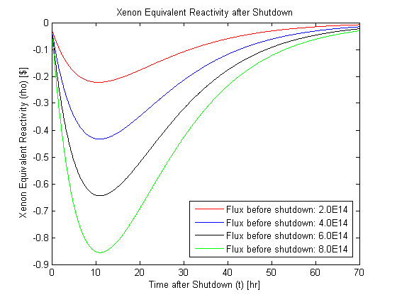

Figure 1 Xenon Equivalent Reactivity after Shutdown

1. Reactor Dead Time
   1. Dead time for fluxes above with max reserve reactivity 0.2

Dead time is distance between zeroes of:

$$-ρ_{reserve}=-\frac{1}{vpϵ}\left[\frac{\left(γ_{I}+γ_{X}\right)ϕ}{ϕ_{X}+ϕ}e^{-λ_{X}t}+\frac{γ_{I}ϕ}{ϕ_{I}-ϕ_{X}}\left(e^{-λ_{X}t}-e^{-λ_{I}t}\right)\right]$$

$$ρ_{reserve}vpϵ=\frac{\left(γ_{I}+γ_{X}\right)ϕ}{ϕ_{X}+ϕ}e^{-λ_{X}t}+\frac{γ_{I}ϕ}{ϕ_{I}-ϕ_{X}}\left(e^{-λ_{X}t}-e^{-λ_{I}t}\right)$$

$$ρ_{reserve}vpϵ=e^{-λ_{X}t}\left(\frac{\left(γ_{I}+γ_{X}\right)ϕ}{ϕ_{X}+ϕ}+\frac{γ_{I}ϕ}{ϕ_{I}-ϕ_{X}}\right)-e^{-λ_{I}t}\frac{γ_{I}ϕ}{ϕ_{I}-ϕ_{X}}$$

Table 1 Selected Deadtimes with flux before shutdown

|  |  |
| --- | --- |
| $$Flux \left(ϕ\right) \left[\frac{n}{cm^{2}s}\right]$$ | $$Deadtime \left(t_{d}\right) \left[hr\right]$$ |
| 2E14 | 16.1 |
| 4E14 | 26.1 |
| 6E14 | 31.3 |
| 8E14 | 34.9 |

* 1. Dead Time vs. Flux Before Shutdown

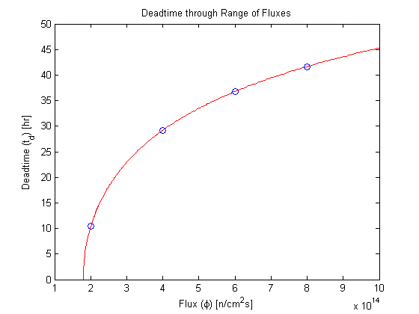

Figure 2 Deadtime vs Flux before Shutdown

1. Dose Rates
   1. Gamma Dose Rate

$$r=1.5m$$

$$α_{I131}=1.5 Ci=5.55*{10}^{10}Bq$$

$$Q=1\frac{rem}{rad} (gamma)$$

$$\dot{X}*Q\left[\frac{mRem}{hr}\right]=0.06591*\sum{p*ϕ*E*{\left(\frac{μ}{ρ}\right)}^{air}}$$

$$E=.636989 MeV and .364489 MeV and .272500 MeV$$

$$ϕ=ϕ_{0}e^{{\left(\frac{μ}{ρ}\right)}^{air}*ρ_{air}*t}$$

$$t=150 cm$$

$$ρ_{air}=0.001275\frac{g}{cm^{3}}$$

$$p=.0717 and .817 and .1113$$

assuming person absorbs dose in all 4pi surrounding source

* 1. Dose rate as function of distance

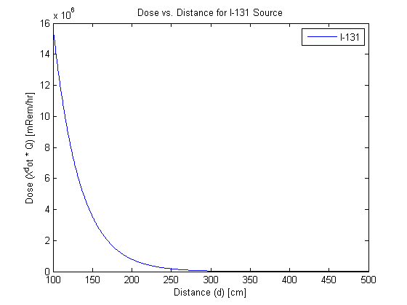

Figure 3 DoSe Rate over Distances from I-131